**Data Driven Decision making system for Supply Chain Management**

Welcome to the comprehensive documentation of our Makeup Products Supply Chain Analytics project! Through meticulous data analysis and the utilization of Tableau's powerful visualization capabilities, we have crafted a series of informative dashboards. These visualizations offer a deep dive into various aspects of the makeup products' supply chain, enabling effective decision-making and strategic planning for the business.

The makeup products' supply chain is multifaceted, encompassing supplier management, inventory control, transportation efficiency, revenue analysis, and more. Our project explores this complexity through the lens of several key perspectives:

**1. Supplier Performance and Financial Perspective:**

In this dimension, we delve into supplier performance metrics, evaluating factors such as revenue generation, manufacturing costs, and lead times. By visually representing supplier rankings and their financial impact, we empower decision-makers to optimize their partnerships, maximize profitability, and ensure efficient supply chain operations.

**2. Revenue and Customer Perspective:**

Understanding customer demographics and their purchasing behaviors is critical for business success. Our analysis provides insights into revenue distribution across customer segments, offering actionable insights for marketing strategies. Additionally, we investigate the connection between defect rates and customer loyalty, facilitating improved customer retention and satisfaction.

**3. Inventory and Efficiency Perspective:**

Effective inventory management and transportation efficiency are paramount to supply chain success. Through visualizations, we explore stock levels, stockouts, and top-selling products. By analyzing transportation costs, carriers, and modes, we guide businesses in identifying cost-effective routes and optimizing logistics.

**4. Supply Chain Optimization and Learning Perspective:**

In the realm of supply chain optimization, we focus on streamlining processes for cost reduction and improved efficiency. Furthermore, our analysis sheds light on the relationship between lead times and sales, aiding in better demand forecasting and inventory management.

This documentation offers a comprehensive journey through our project's insights, illustrated through a series of interactive dashboards. By employing Tableau's visualization capabilities, we provide clear, data-driven narratives that empower businesses to make informed decisions and enhance their makeup products' supply chain performance. Whether it's optimizing supplier relationships, improving customer satisfaction, or achieving cost efficiency, our project equips decision-makers with the tools to navigate the complex landscape of supply chain management.

**Technical Architecture:**

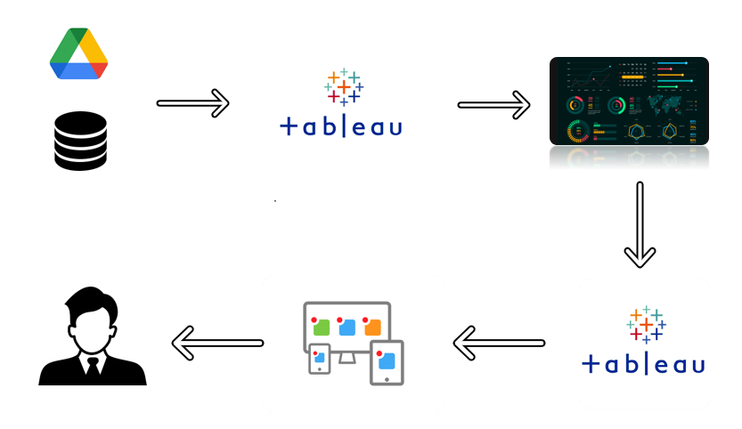

**Project Flow**

To accomplish this, we have to complete all the activities listed below,

* **Define Problem / Problem Understanding**
  + Specify the business problem
  + Business requirements
  + Literature Survey
  + Social or Business Impact.
* **Data Collection & Extraction from Database**
  + Collect the dataset,
  + Connect dataset with Tableau
* **Data Preparation**
  + Prepare the Data for Visualization
* **Data Visualizations**
  + No of Unique Visualizations
* **Dashboard**
  + Responsive and Design of Dashboard
* **Story**
  + No of Scenes of Story
* **Performance Testing** 
  + Amount of Data Rendered to DB ‘
  + Utilization of Data Filters
  + No of Calculation Fields
  + No of Visualizations/ Graphs
* **Web Integration**
  + Dashboard and Story embed with UI With Flask
* **Project Demonstration & Documentation**
  + Record explanation Video for project end to end solution
  + Project Documentation-Step by step project development procedure

**Milestone 1: Define Problem / Problem Understanding**

**Activity 1: Specify the business problem**

Refer Project Description

**Activity 2: Business requirements**

The Makeup Products Supply Chain Analytics project's business requirements encompass a comprehensive dataset covering supplier information, inventory, transportation, revenue, costs, and customer demographics. Through interactive visualizations, the project aims to offer insights into supplier performance, customer preferences, inventory management, and supply chain optimization. The user-friendly interface ensures easy navigation and customizable reports, enhancing decision-making. Data security, scalability, integration capabilities, and high-performance processing form the foundation for delivering valuable insights to supply chain managers, enabling them to make informed decisions, optimize operations, and achieve cost-effective, efficient, and successful supply chain management.

**Activity 3: Literature Survey (Student Will Write)**

The Makeup Products Supply Chain Analytics project undertakes a comprehensive literature survey to explore existing research and studies relevant to supply chain management, performance analysis, and data visualization techniques. Numerous studies have delved into diverse facets of supply chain optimization, supplier analysis, and inventory management across various industries. Additionally, research on performance evaluation methodologies and metrics in supply chain operations has yielded valuable insights for our project. Furthermore, literature on data visualization tools and best practices has been examined to effectively convey intricate supply chain information to stakeholders.

Scholars have underscored the significance of financial perspectives in supply chain management, underscoring the need for businesses to make informed financial decisions throughout the supply chain process. Furthermore, research on learning and growth perspectives in supply chain management has provided insights into continuous improvement strategies, talent development, and performance enhancement. By amalgamating insights from these sources, the project integrates a comprehensive range of findings into the Tableau visualizations, offering a holistic and insightful exploration of the Makeup Products Supply Chain Analytics**.**

**Activity 4: Social or Business Impact.**

The Makeup Products Supply Chain Analytics project holds significant potential for both social and business impact.

**From a social perspective,** the project's insights can contribute to more efficient and sustainable supply chain practices. By optimizing inventory levels, reducing transportation costs, and enhancing supplier collaboration, the project can indirectly contribute to minimizing environmental footprints through reduced resource consumption and emissions. Additionally, by ensuring product availability and timely deliveries, the project can enhance customer satisfaction and loyalty, thus improving overall consumer experiences.

**From a business standpoint,** the project's impact is substantial. Effective supply chain management leads to cost savings through optimized inventory and transportation, directly impacting the bottom line. By identifying profitable product categories, high-performing suppliers, and cost-effective transportation modes, businesses can allocate resources more strategically. Moreover, the project aids in decision-making, helping companies avoid stockouts, reduce defects, and streamline operations, ultimately contributing to higher profitability. The insights gained also enable businesses to make informed expansion or scaling decisions and adapt to changing market conditions, leading to sustained growth and competitiveness. Overall, the Makeup Products Supply Chain Analytics project has the potential to transform both social and business dimensions by fostering more efficient, responsible, and successful supply chain practices.

**Milestone 2: Data Collection & Extraction from Database**

Data collection is the process of gathering and measuring information on variables of interest, in an established systematic fashion that enables one to answer stated research questions, test hypotheses, and evaluate outcomes and generate insights from the data.

**Activity 1: Collect the dataset**

Please use the link to download the dataset:

<https://www.kaggle.com/datasets/harshsingh2209/supply-chain-analysis>

**Activity 1.1: Understand the data**

The dataset employed in this project encompasses a comprehensive array of attributes, each capturing a distinct facet of the makeup products' supply chain. The following are the key features embedded within the dataset:

1. **Product Type:** Segmentation of makeup products into categories like haircare, skincare, and cosmetics.

2. **SKU**: A distinctive identifier assigned to each makeup product, pivotal for inventory tracking and sales monitoring.

3. **Price**: The designated selling price of individual makeup products, integral for revenue computation.

4. **Availability**: Depicts the stock quantity of a specific product available within the inventory.

5. **Number of products sold**: Reveals the quantity of each makeup product that has been successfully sold.

6. **Revenue generated**: The cumulative revenue accrued from the sales of each product type.

7. **Customer demographics**: Categorizes clientele into groups such as male, female, non-binary, or unknown.

8. **Stock levels**: Illuminates the current inventory count for each makeup product.

9. **Lead times**: Represents the time interval from product initiation to its arrival at the customer's doorstep.

10. **Order quantities**: Quantifies the units of each makeup product included in a particular transaction.

11. **Shipping times**: Gauges the time required for successful shipping and delivery to the customer.

12. **Shipping carriers:** Designates the entities responsible for the transportation of products.

13. **Shipping costs**: Identifies the financial implications associated with product transportation.

14. **Supplier name**: Specifies the name of the supplier or manufacturer.

15. **Location**: Specifies the geographic locale of the supplier.

16. **Manufacturing lead time**: Unveils the duration necessary for the complete manufacturing of products.

17. **Production volumes**: Discloses the total quantity of products that have been manufactured.

18. **Manufacturing costs**: Enumerates the expenses incurred during the product manufacturing process.

19**. Inspection results**: Illuminates the outcomes of quality control inspections.

20. **Defect rates**: Computes the proportion of defective products identified during inspections.

21. **Transportation modes**: Distinguishes the diverse modes of transportation utilized for product movement.

22. **Routes:** Outlines the specific trajectories taken by products during their transit.

23. **Costs**: Quantifies the assorted expenses associated with product transportation.

**Activity 2: Connect Dataset to Tableau**

Explanation video link:

<https://drive.google.com/file/d/1qE9rcdwmkmu0ihn00PoX4CfAWTkvv0HB/view?usp=sharing>

**Milestone 3: Data Preparation**

**Activity 1: Prepare the Data for Visualization**

Preparing the data for visualization involves cleaning the data to remove irrelevant or missing data, transforming the data into a format that can be easily visualized, exploring the data to identify patterns and trends, filtering the data to focus on specific subsets of data, preparing the data for visualization software, and ensuring the data is accurate and complete. This process helps to make the data easily understandable and ready for creating visualizations to gain insights into the performance and efficiency.

**Colab File:** <https://colab.research.google.com/drive/1WYuZsucQchSGlQOUwu9gXitJ4K9eHKsx?usp=sharing>

**Colab File explanation for the same:**

<https://drive.google.com/file/d/1IWH0PGdE54Qg_p23ivo0Bn-K2zmnr00S/view?usp=sharing>

**Milestone 4: Data Visualization**

Data visualization is the process of creating graphical representations of data in order to help people understand and explore the information. The goal of data visualization is to make complex data sets more accessible, intuitive, and easier to interpret. By using visual elements such as charts, graphs, and maps, data visualizations can help people quickly identify patterns, trends, and outliers in the data.

**Activity 1: No of Unique Visualizations**

The number of unique visualizations that can be created with a given dataset. Some common types of visualizations that can be used to analyse the Supply Chain data include bar charts, line charts, heat maps, scatter plots, pie charts, Maps etc. These visualizations can be used to compare performance, track changes over time, show distribution, and relationships between variables.

**Activity 1.1:** **Supplier Ranking**

**Explanation video link:** [**https://drive.google.com/file/d/1Gn1FT65pJOz0rEM38Y5EJWN2kk12Q9cR/view?usp=sharing**](https://drive.google.com/file/d/1Gn1FT65pJOz0rEM38Y5EJWN2kk12Q9cR/view?usp=sharing)

[**https://drive.google.com/file/d/1bnsTpjKAyY58rHO3R265ONPqToHv_Mul/view?usp=sharing**](https://drive.google.com/file/d/1bnsTpjKAyY58rHO3R265ONPqToHv_Mul/view?usp=sharing)

**Activity 1.2: Supplier Location Revenue and Final Cost Analysis**

**Explanation video link:** [**https://drive.google.com/file/d/1gUQqsHqVNOt6keFrwfVRTJe-pCyrAwca/view?usp=sharing**](https://drive.google.com/file/d/1gUQqsHqVNOt6keFrwfVRTJe-pCyrAwca/view?usp=sharing)

**Activity 1.3: Production volume**

**Explanation video link:** [**https://drive.google.com/file/d/1zMTvtmojEGljduDeogmb6ih4fpzsRUr7/view?usp=sharing**](https://drive.google.com/file/d/1zMTvtmojEGljduDeogmb6ih4fpzsRUr7/view?usp=sharing)

**Activity 1.4: Inspection Result on revenue**

**Explanation video link:** <https://drive.google.com/file/d/1JH9e4CIDUcDM-ZuwR_QnishP-wMez7bt/view?usp=sharing>

**Activity 1.5: Revenue generated by product type**

**Explanation video link:** <https://drive.google.com/file/d/1JH9e4CIDUcDM-ZuwR_QnishP-wMez7bt/view?usp=sharing>

**Activity 1.6: Top 5 SKU for skincare**

**Explanation video link:** [**https://drive.google.com/file/d/1Jy9YhghV6Y918F8rCmg-wjVpuhTnXhU4/view?usp=sharing**](https://drive.google.com/file/d/1Jy9YhghV6Y918F8rCmg-wjVpuhTnXhU4/view?usp=sharing)

**Activity 1.7: Price Analysis**

**Explanation video link:** <https://drive.google.com/file/d/19sTVDJmHBxzjK1uSQkmgZ4Vzs891SqWR/view?usp=sharing>

**Activity 1.8: Revenue Across Customer Demographics**

**Explanation video link:** <https://drive.google.com/file/d/1rhtjP1iBpka-CDU0KWzasbJUd-wGZcpl/view?usp=sharing>

**Activity 1.9: Top Defect Rates of SKUs**

**Explanation video link:** <https://drive.google.com/file/d/1VcVuT5XLENd2rgL5XzfzYxxaveTJy6zu/view?usp=sharing>

**Activity 1.10: Stock Level Analysis by SKU**

**Explanation video link:** <https://drive.google.com/file/d/18QBnNPqB1_J6GXg_ucJyAn1JUTcmwrCa/view?usp=drive_link>

**Activity 1.11: Top 20 Products Sales Analysis: SKU Availability vs. Stock Level**

**Explanation video link:** <https://drive.google.com/file/d/1nDS3PBbAE89FB1QMJeNK36JvWwTUs8Bc/view?usp=drive_link>

**Activity 1.12: Transport Efficiency Analysis: Cost, Time, Product Type & Defect Rate**

**Explanation video link:** <https://drive.google.com/file/d/1FwWcq4JUXybg8fBIOhIR1BGhvkShT-Z1/view?usp=drive_link>

**Activity 1.13: Transportation Cost Allocation**

**Explanation video link:** <https://drive.google.com/file/d/1RnjZOhHjfQd8Ku1Agogxv0N_JcQH0YmJ/view?usp=drive_link>

**Activity 1.14: Order Quantity vs Total Shipping Cost**

**Explanation video link:** <https://drive.google.com/file/d/1MBjeDwLkXZ1-63aFZuzMGLqnb0F7V0ZR/view?usp=drive_link>

**Activity 1.15: Lead Times Impact on Sales**

**Explanation video link:** <https://drive.google.com/file/d/1rxr4yv_xqbK0LTy2-PVsrQrkR62I-lRS/view?usp=drive_link>

**Activity 1.16: Defect Rates by Transportation Modes**

**Explanation video link:** <https://drive.google.com/file/d/1iPM4nEkp12Rbv1Eql7uU7JdDI-CYh8r8/view?usp=drive_link>

**Milestone 5: Dashboard**

A dashboard is a graphical user interface (GUI) that displays information and data in an organized, easy-to-read format. Dashboards are often used to provide real-time monitoring and analysis of data, and are typically designed for a specific purpose or use case. Dashboards can be used in a variety of settings, such as business, finance, manufacturing, healthcare, and many other industries. They can be used to track key performance indicators (KPIs), monitor performance metrics, and display data in the form of charts, graphs, and tables.

**Activity :1- Responsive and Design of Dashboard**

Explanation video link:

<https://drive.google.com/file/d/1JpH8tas871lYJb5W8gYEmWCR_K51mepT/view?usp=drive_link>

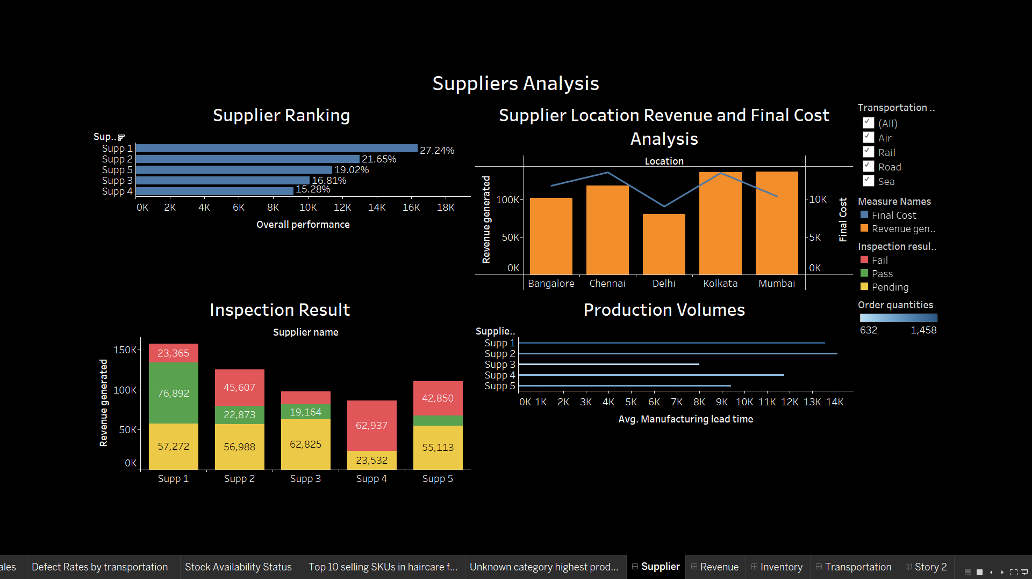

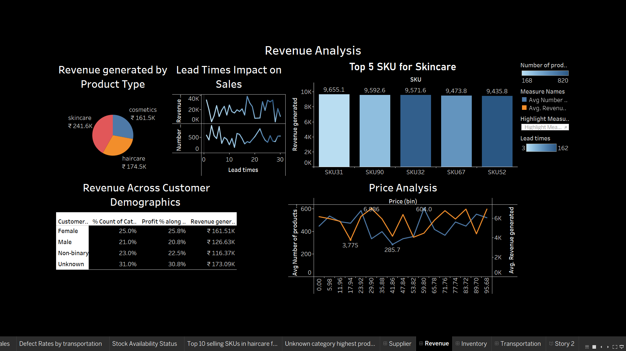

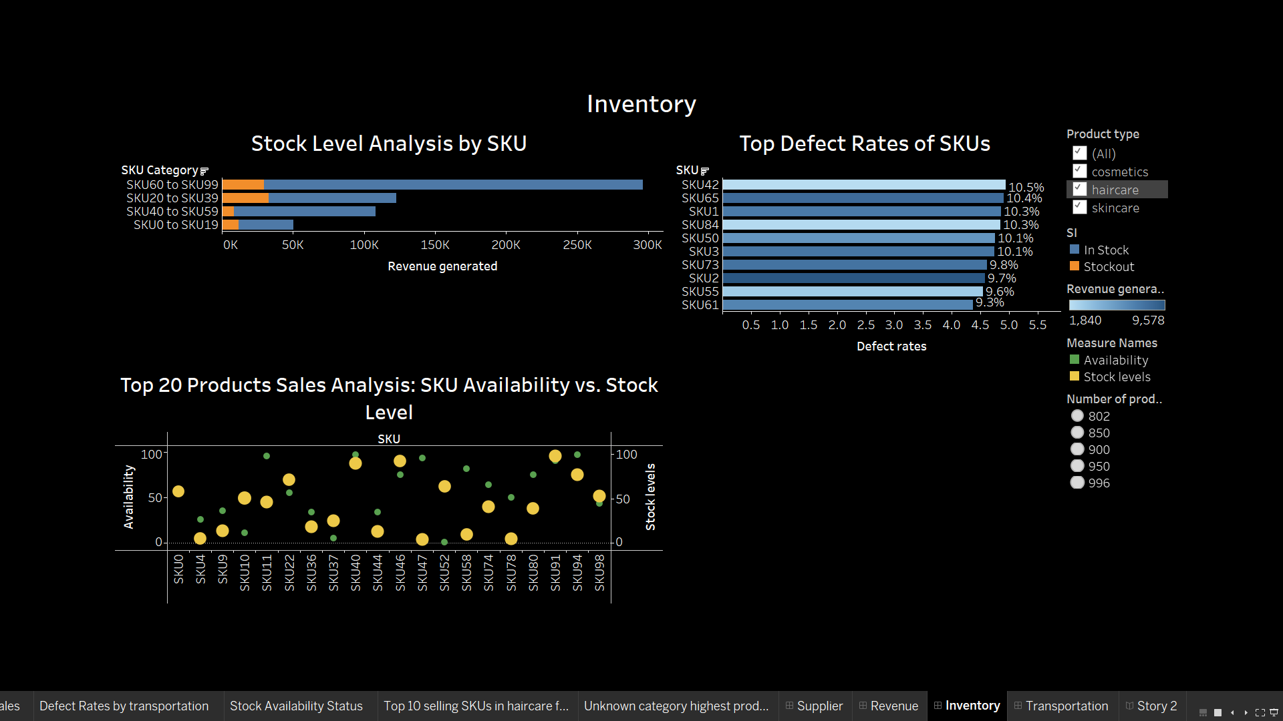

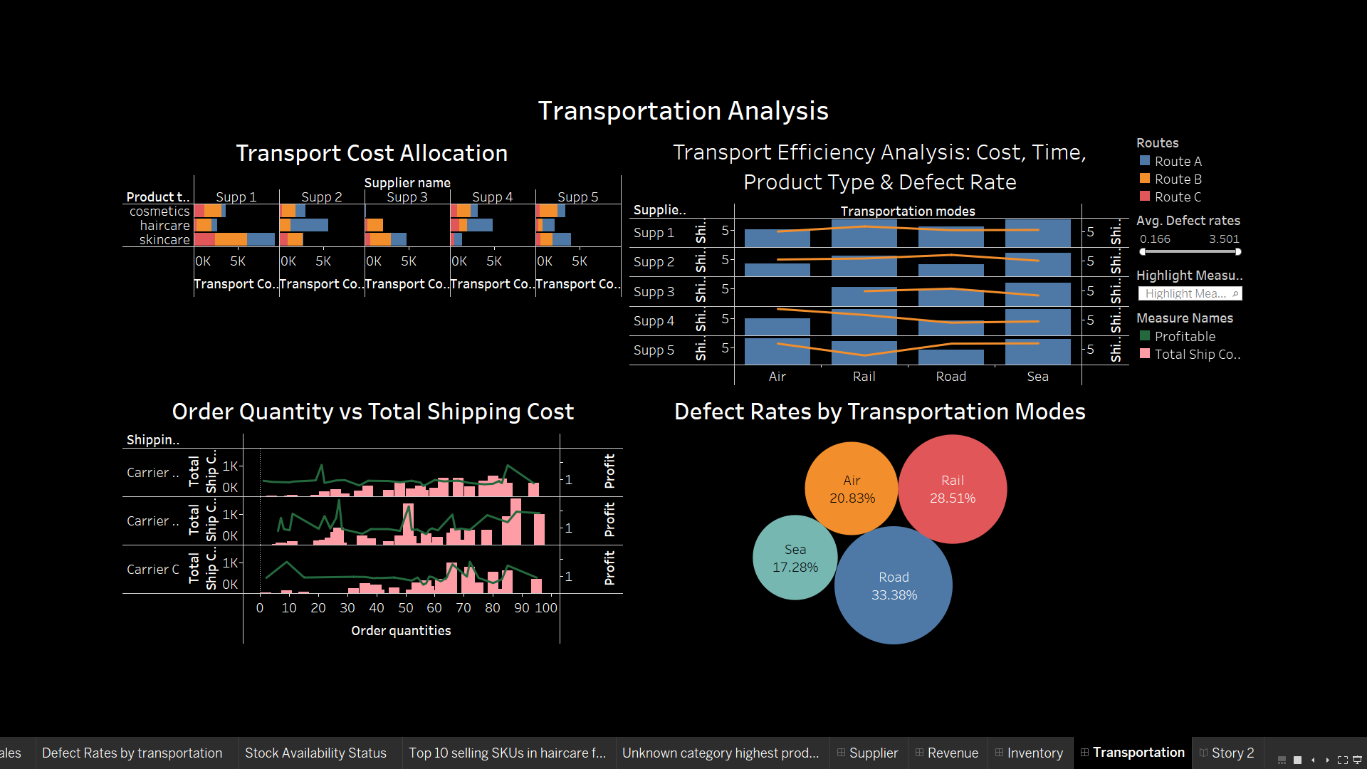

**Milestone 6: Story**

A data story is a way of presenting data and analysis in a narrative format, with the goal of making the information more engaging and easier to understand. A data story typically includes a clear introduction that sets the stage and explains the context for the data, a body that presents the data and analysis in a logical and systematic way, and a conclusion that summarizes the key findings and highlights their implications. Data stories can be told using a variety of mediums, such as reports, presentations, interactive visualizations, and videos.

**Activity:1- No of Scenes of Story**

The number of segments within a storyboard designed for the data visualization analysis of supply chain management factors influencing makeup product production insights will be contingent upon the intricacy of the analysis and the precise insights intended for communication. The storyboard serves as a graphical depiction of the data analysis journey, dissecting the analysis into a sequence of distinct steps or scenes.

**Explanation video link:**

<https://drive.google.com/file/d/1VWvLELa5EFtSQkmsI7DwLhWZbjOt-SMb/view?usp=drive_link>

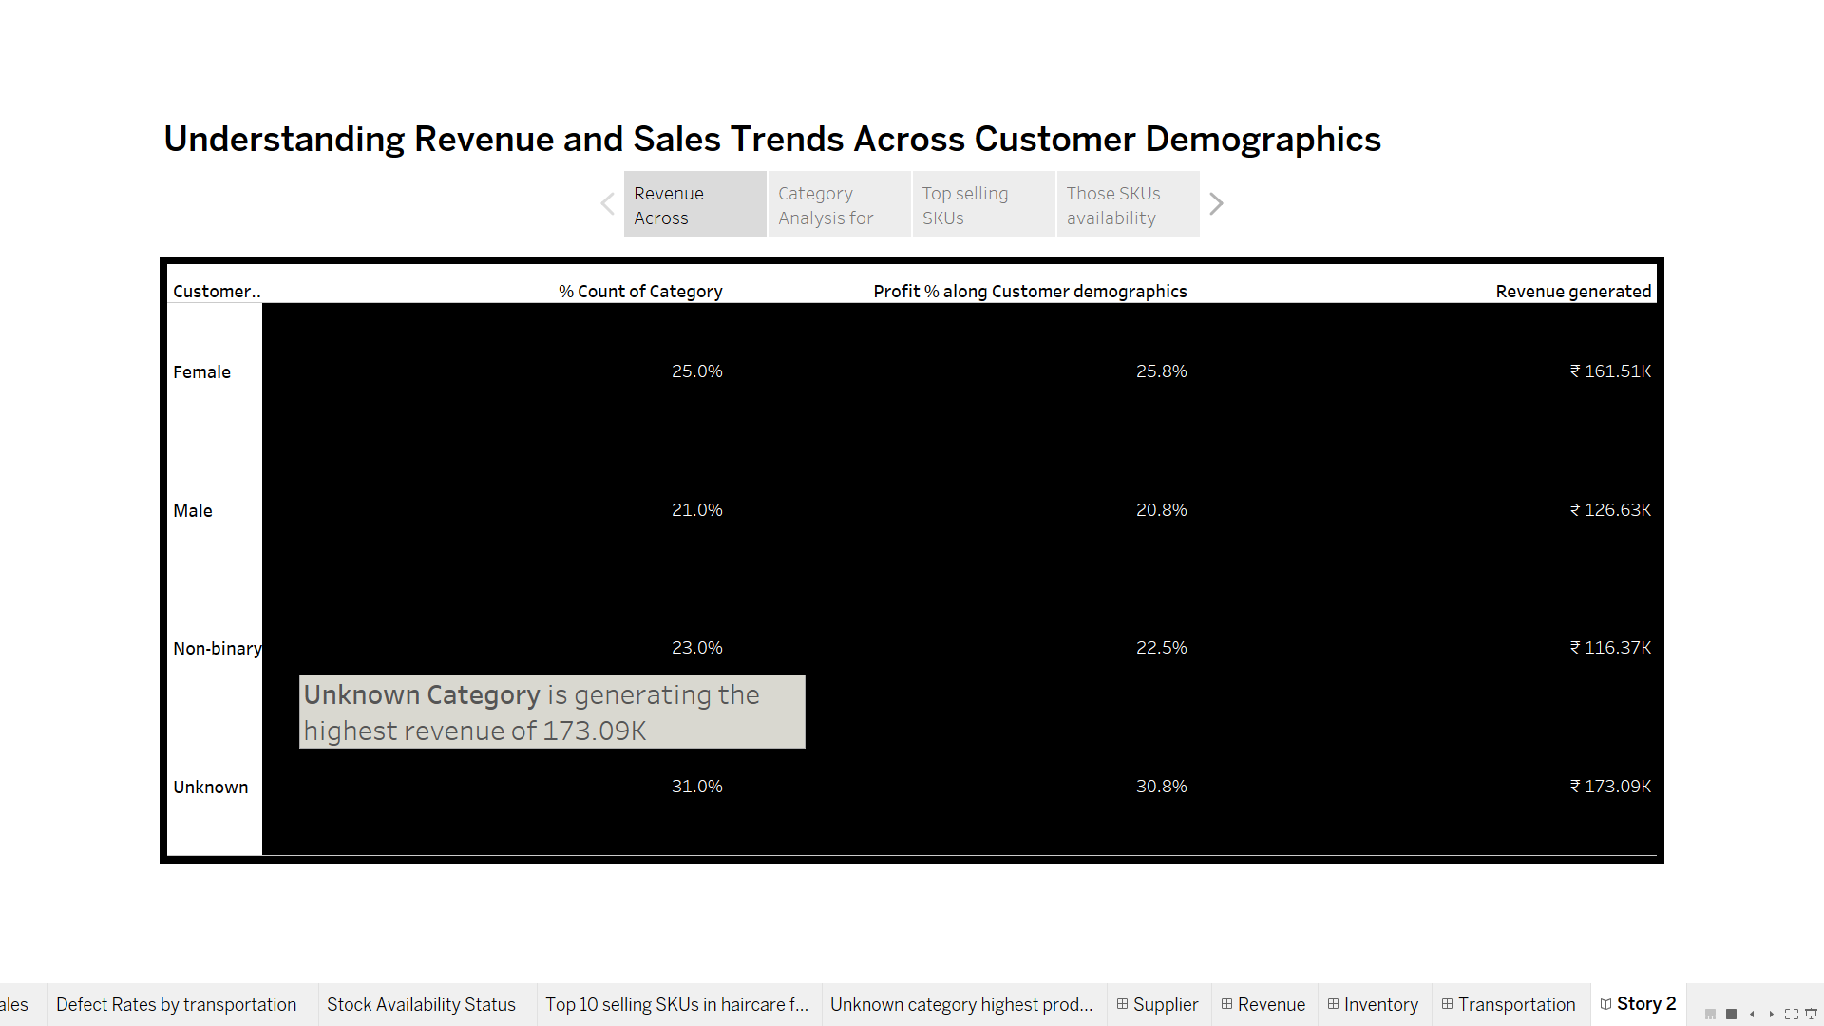

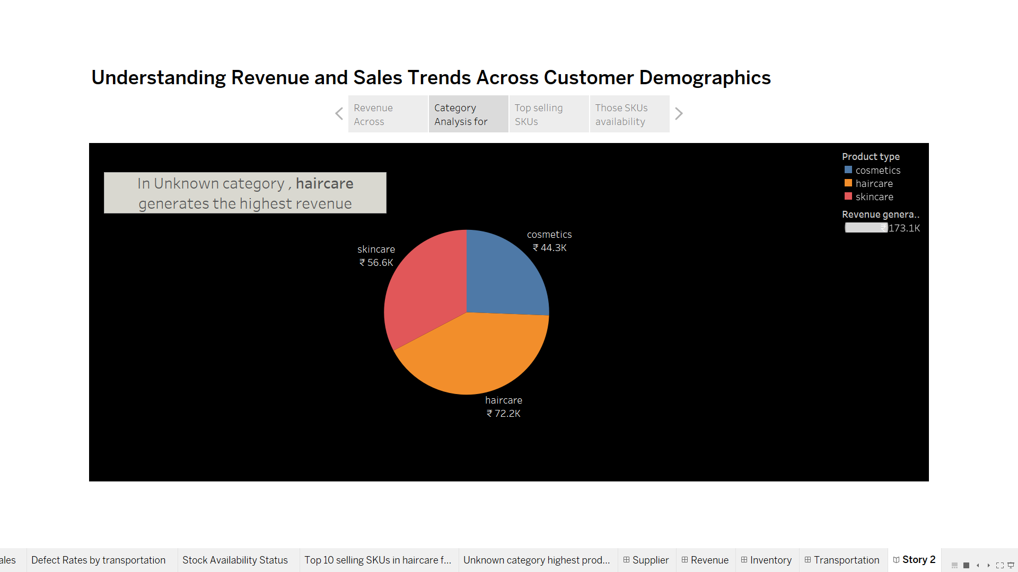

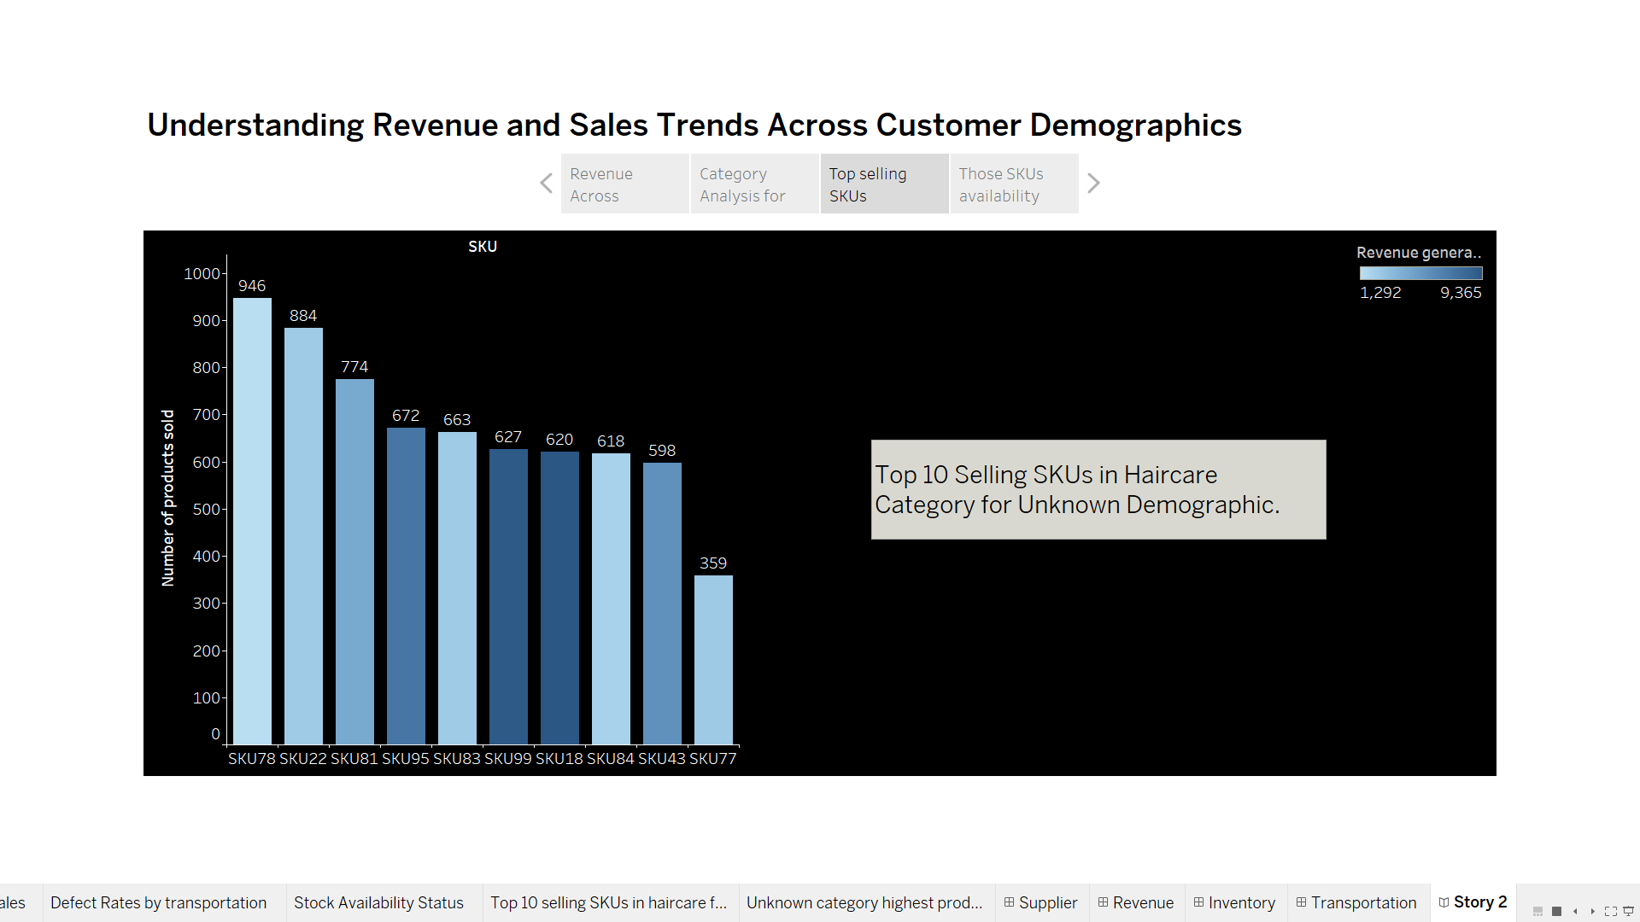

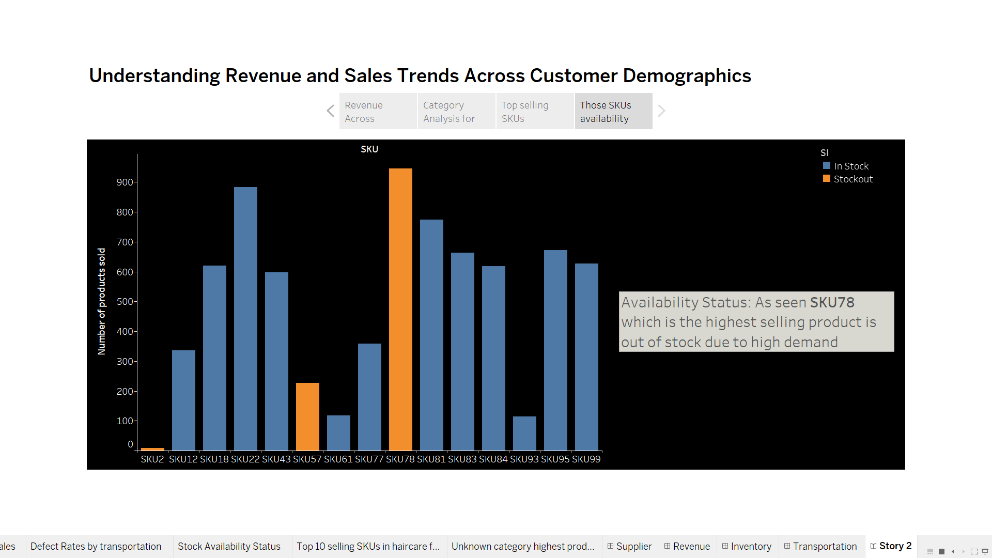

**Milestone 8: Performance Testing**

**Activity 1: Utilization of Data Filters**

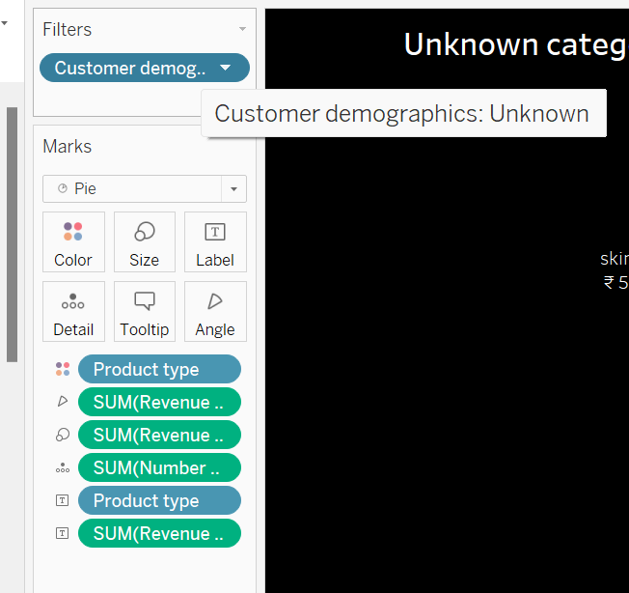

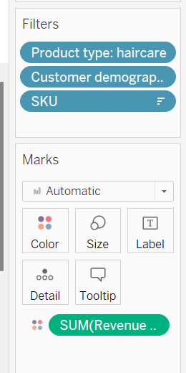

**Activity 3: No of Calculation Fields**

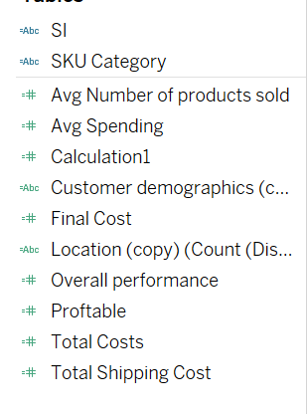

**Activity 4: No of Visualizations/ Graphs**

1. Supplier Ranking
2. Supplier Location Revenue and Final Cost Analysis
3. Production volume
4. Inspection Result on revenue
5. Revenue generated by product type
6. Top 5 SKU for skincare
7. Price Analysis
8. Revenue Across Customer Demographics
9. Top Defect Rates of SKUs
10. Stock Level Analysis by SKU
11. Top 20 Products Sales Analysis: SKU Availability vs. Stock Level
12. Transport Efficiency Analysis: Cost, Time, Product Type & Defect
13. Transportation Cost Allocation
14. Order Quantity vs Total Shipping Cost
15. Lead Times Impact on Sales
16. Defect Rates by Transportation Modes

**Milestone 9: Web integration**

Publishing helps us to track and monitor key performance metrics, to communicate results and progress. help a publisher stay informed, make better decisions, and communicate their performance to others.

**Integrating dashboard/reports/stories to web**

Step 1: Go to **Tableau** and click on the server and publish your workbook .

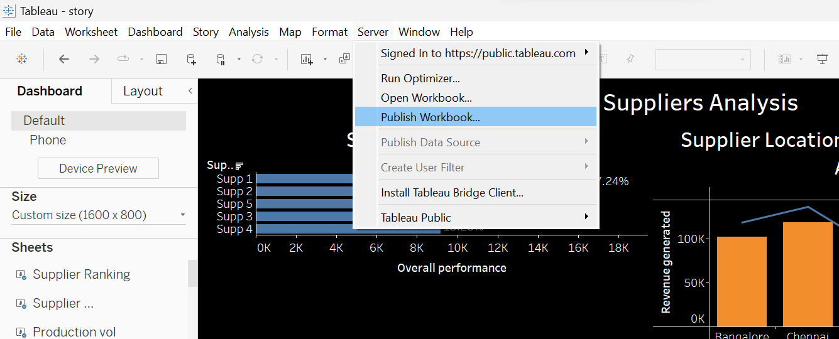

Step 2: Then enter your tableau public credentials. The sheet will be published to your tableau public account.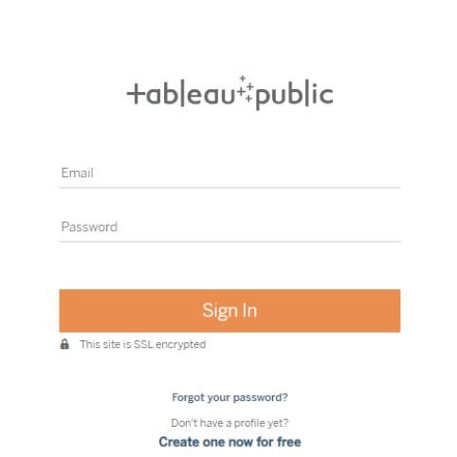

* Once you login into your tableau public using the credentials, the particular visualization will be published into the tableau public

**Note: While publishing the visualization to the public, the respective sheet will get published when you click on the share option.**

Step 3: Copy the link and paste it in your html page.

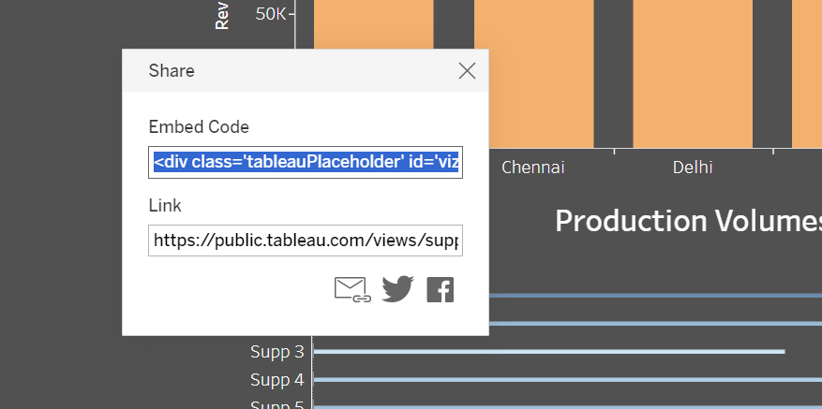

**Activity 1: Dashboard and Story embed with UI**

1. You have to Publish your sheet in your tableau public account.
2. Once you publish it, get the link as shown in the video below and paste it in your html code.
3. Then the sheets are displayed.

**Explanation video link:**[**https://drive.google.com/file/d/1eUxzQnkHQYBg_gJeUgtmB_X3RWdt-Qfc/view?usp=drive_link**](https://drive.google.com/file/d/1eUxzQnkHQYBg_gJeUgtmB_X3RWdt-Qfc/view?usp=drive_link)

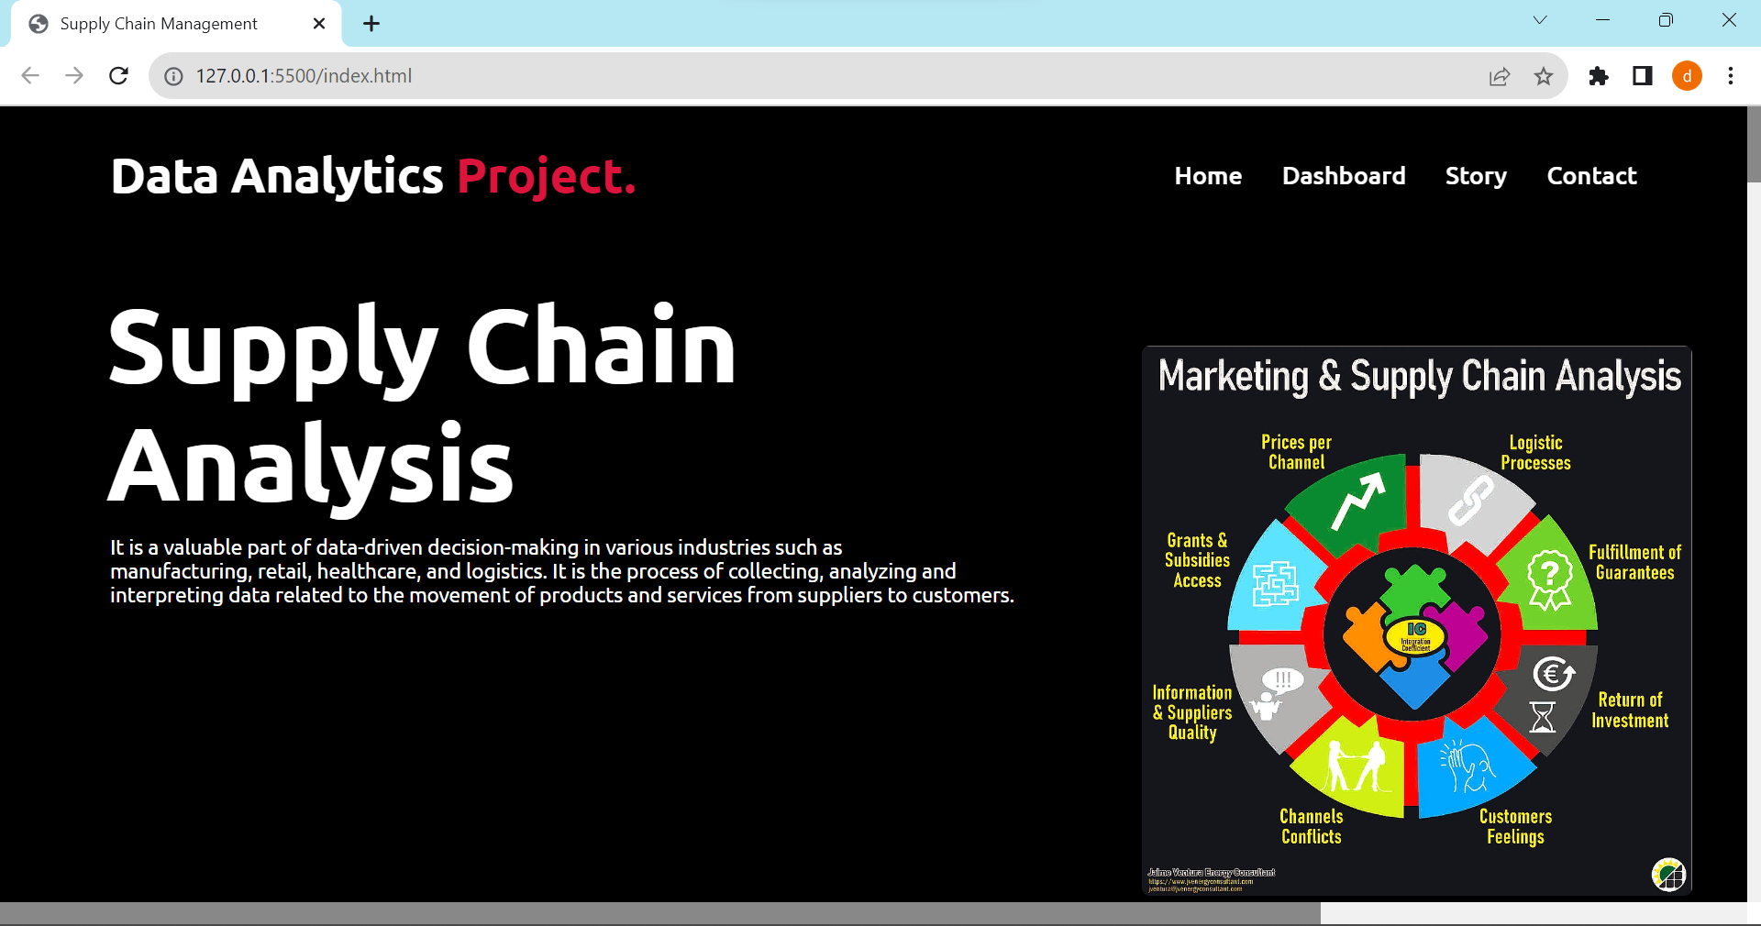

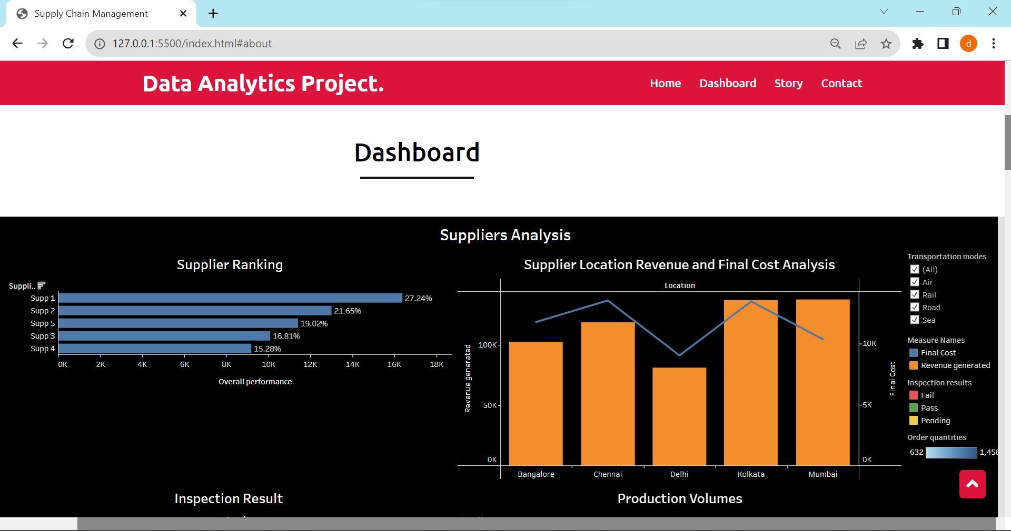

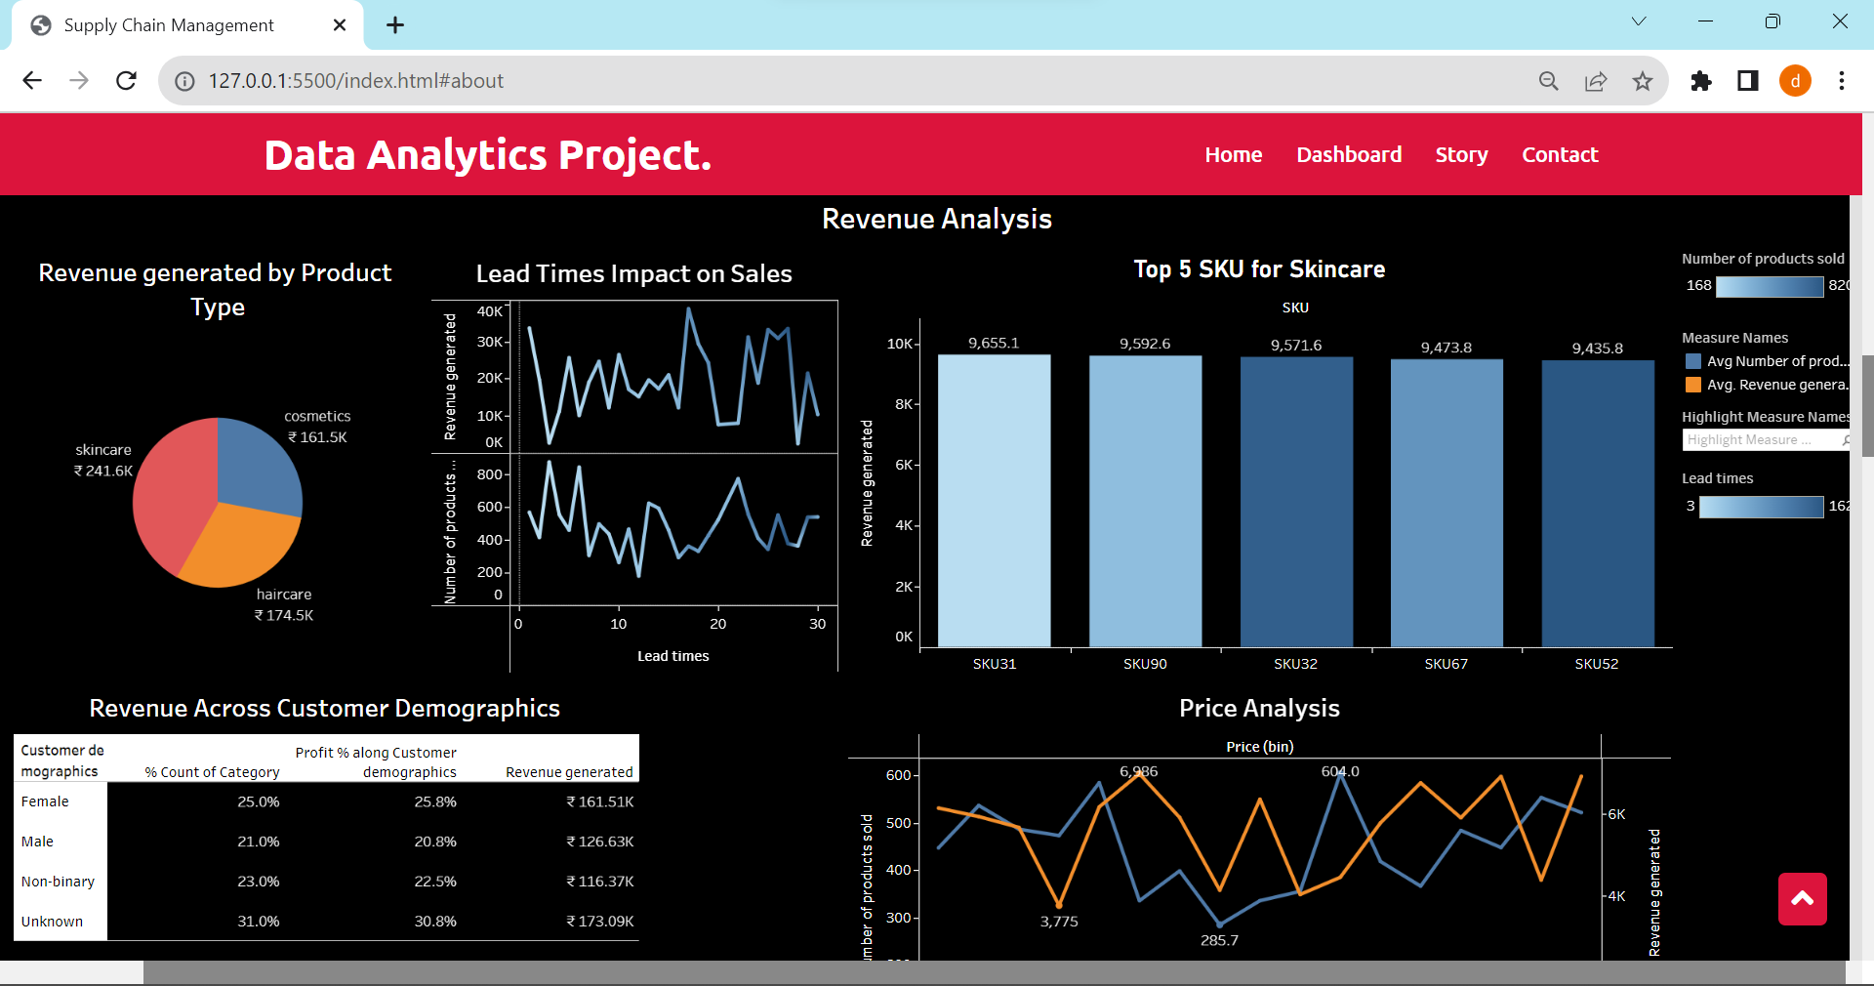

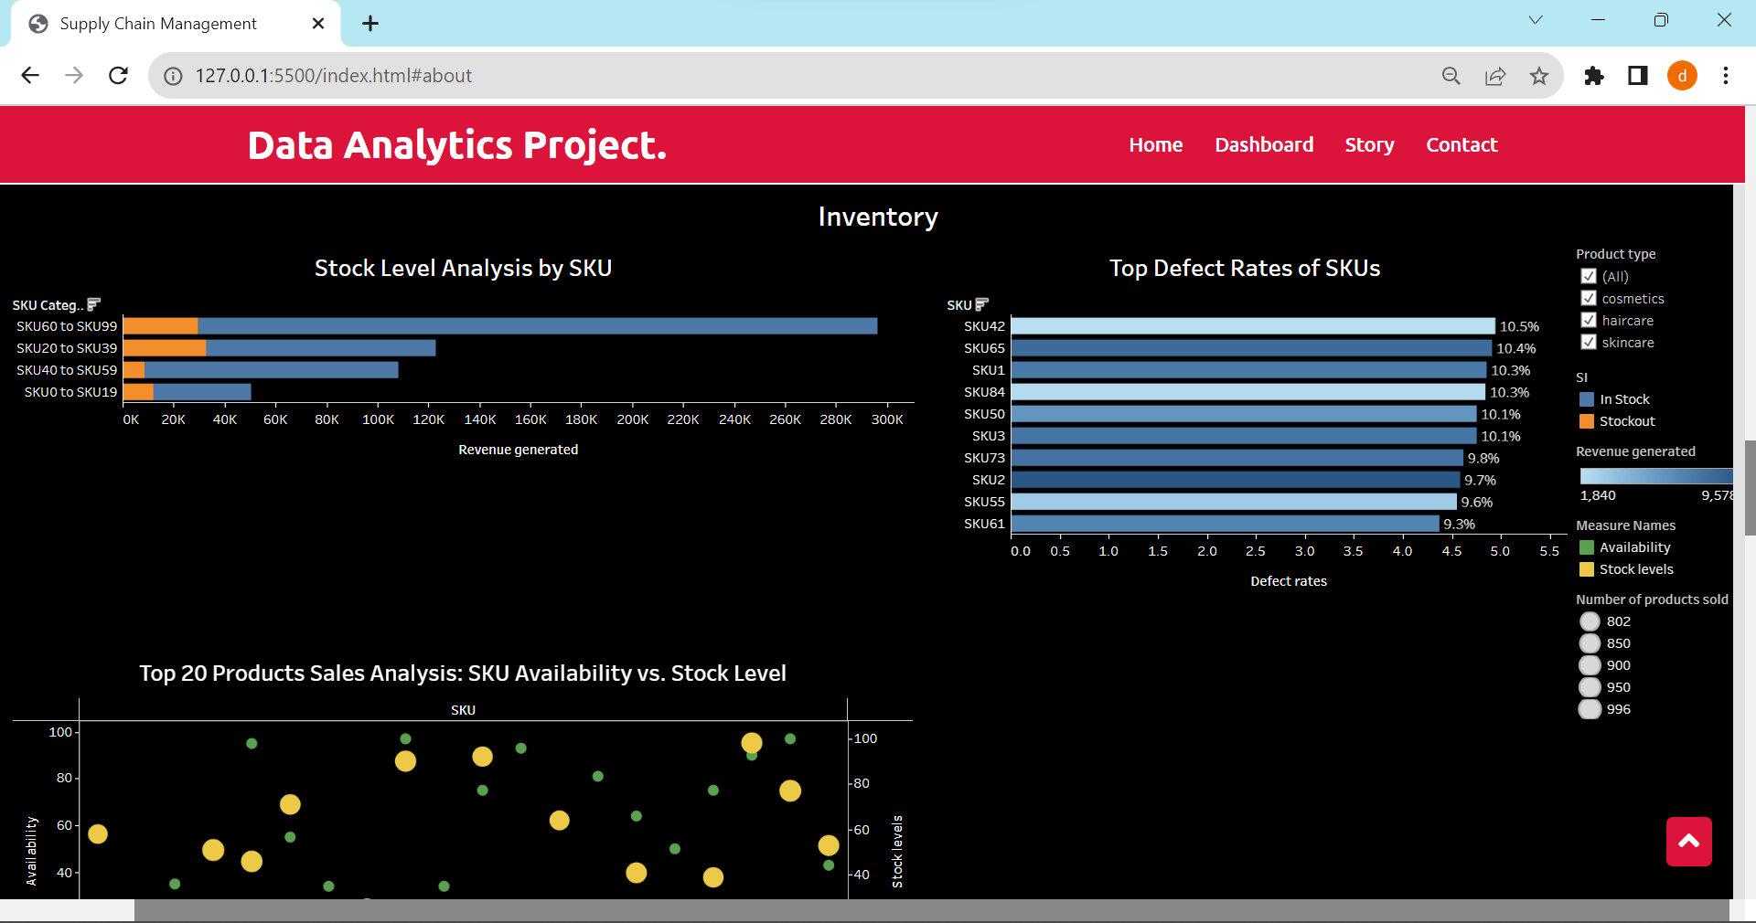

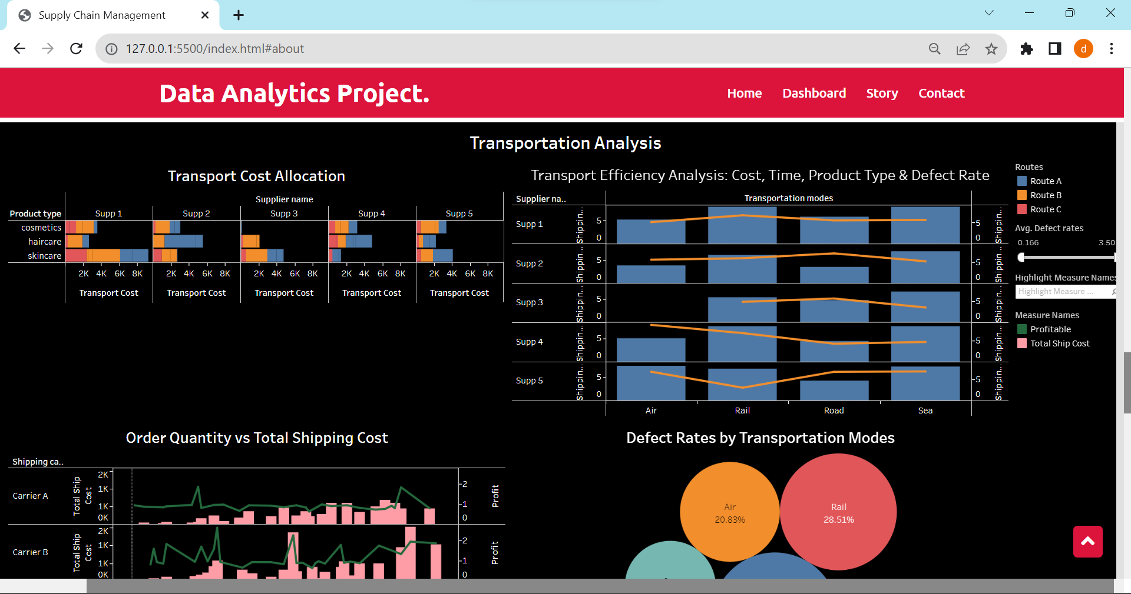

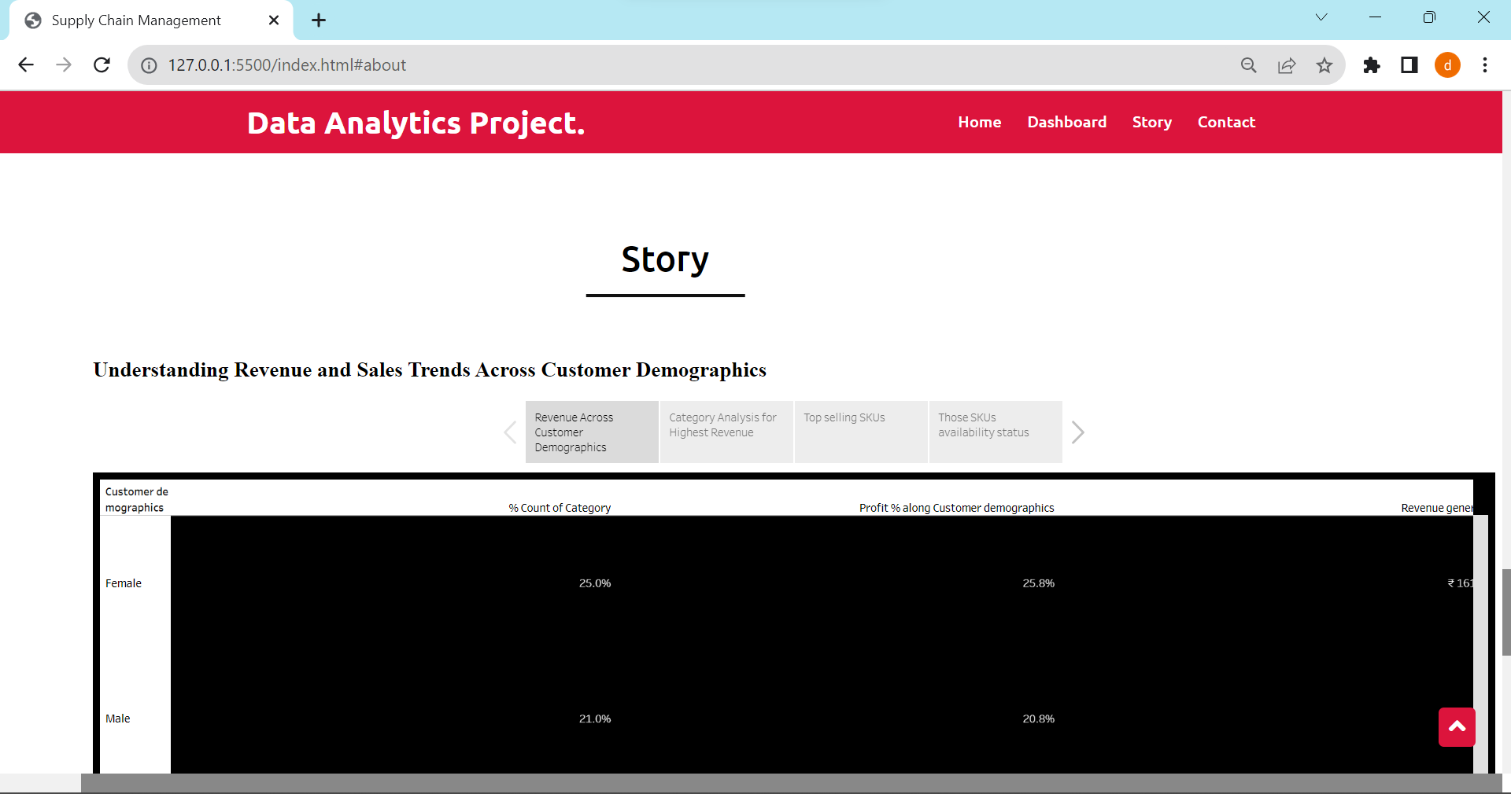

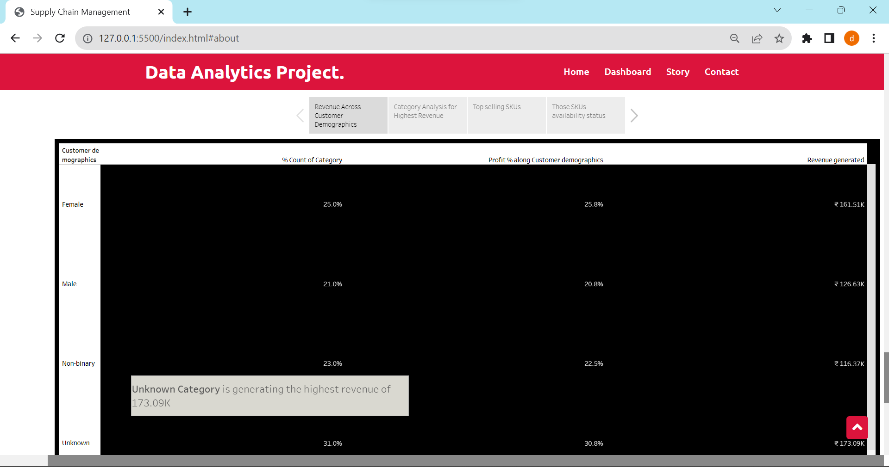

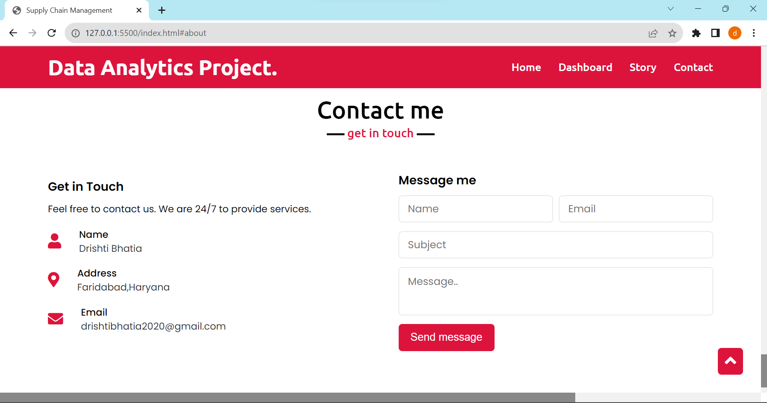

**Milestone 10: Project Demonstration & Documentation**

Below mentioned deliverables to be submitted along with other deliverables

**Activity 1:- Record explanation Video for project end to end solution**

**Activity 2:- Project Documentation-Step by step project development procedure**

Create document as per the template provided